BTEC Public Services Level 2
Homework Book
Unit 1 Book 1
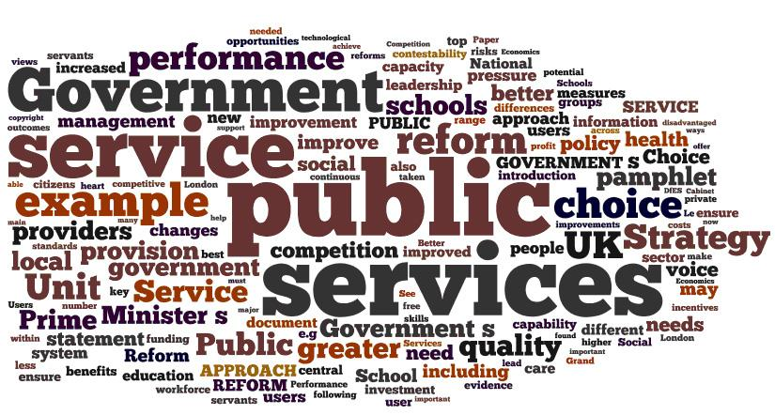
Exploring the Public Services and their Work
Name:_________________ Date:__________________

Task 1 – the grouping of Public Services
It is important to remember that there are five different groups of public services. You may be asked in the exam to give specific examples. Complete the table below by grouping the public services by their types. Use the list at the bottom of the page to help you if you need it!
Emergency Services | Armed Services | Local Authorities | Central Government | Third Sector  (Voluntary)

Public Services:
Red Cross, Fire & Rescue, Royal Navy, Territorial Army, British Army, Town Councils, Unitary Authorities, Royal Air Force, Parliament, NSPCC, Welsh Assembly, Shelter, Cancer Research, County Councils, Royal Navy Reserves, Ambulance, Police, City Councils, Royal National Lifeboat Institution (RNLI), St John Ambulance, Royal Air Force Reserves, Mountain Rescue, Royal Voluntary Service, British Heart Foundation

Task 2 – The purpose of the Public Services
You will also need to know the purpose of each of the public service groups. For each of the groups below, there are two descriptions of their purpose. Draw a line to match them up. The first one is done for you....
Respond to incidents, accidents or emergencies
Emergency Services
Education, social services & child protection
Defend the UK

Armed Services
Local Authorities
Central Government
Third Sector
Support the emergency services

Provide non-emergency support

Prevent incidents, accidents or emergencies

Support international peacekeeping

Report to government ministers
Leisure, culture and entertainment facilities

Oversee transport, education & environmental health

Task 3A – The work and responsibilities of the Public Services
The work of the public services generally falls into three categories. Use your textbook to provide a definition and example of the following:
Statutory (legal) Responsibilities:

________________________________________________________
________________________________________________________
________________________________________________________
________________________________________________________
Non-statutory Responsibilities:

________________________________________________________
________________________________________________________
________________________________________________________
________________________________________________________
Contracted-out services:

________________________________________________________
________________________________________________________
________________________________________________________
________________________________________________________
Task 3B - Using the internet, research the following Public Services and give examples of services that they offer:
Fire & Rescue – Statutory Services
Local Council – Statutory Services
NHS – Non-statutory Services
Voluntary / Third Sector – Non-statutory Services
Task 4 - Research each of the voluntary services listed below. For each, identify what the service does and which group of services it supports. One has already been completed for you.
Voluntary service | What does this service do? | Which group of services does this service support?
E.g., St John Ambulance | E.g., provides medical support at big events and first aid training to individuals | E.g., the emergency services
Mountain Rescue
Cancer Research UK
British Red Cross
Shelter
Task 5 - Use the internet and text books to find out what work the following public services do in your local area:
Department for Education

Department for Business, Innovation & Skills

National Health Service

Public Health Service

Department for Environment, Food & Rural Affairs (DEFRA)

Justice Services

Ministry of Defence

Home Office

HM Revenue & Customs

Social Services

Local Authority (Leisure & Heritage Team)

Community Protection team (Police, local authorities & environmental health)

Task 6 – Ministers responsible for the Public Services
Can you work out which public services each of the government Ministers below is in charge of? You should also find out which department they work in. The first one has been started for you.
It may help to look them up and find out what they do....
Minister | Department | Public Services
Minister of State for the Armed Services | Ministry of Defence
Minister for Local Government
Minister of State for Policing & the Fire Service
Minister for Health
Minister for Education

Revision quiz
BTEC Level 2 First Public Services: Unit 1
Surname: |  | Forename:

Instructions
- Write your name in the table above.
- Answer all questions.
- Write your answers in the spaces provided.

Information and advice
- The number of marks that each question is worth is shown in brackets on the right hand side of the page.
- Read each question carefully.
- These practice questions are not actual exam questions but have styled in a similar style as a practice aid.

- The public services can be grouped by the type of work they do. Draw a line to match each public service to the correct grouping.
Local authority
Voluntary services
Royal Naval Reserves
Armed services
Shelter
Central government
Emergency services

(Total for Question 1 = 2 marks)

- (a) (i) The purpose of the armed services is to defend the UK.
Name two services that are overseen by the Ministry of Defence. (2)

1 ________________________________________________________________________

2 ________________________________________________________________________

(ii) Explain how the armed services support the civilian services. (2)
_________________________________________________________________________
_________________________________________________________________________
_________________________________________________________________________
_________________________________________________________________________
(b) Identify why the voluntary sector is sometimes called ‘the third sector’. (1)

_________________________________________________________________________
_________________________________________________________________________

(c) List and explain three key roles and responsibilities delivered by the Ambulance Service. (6)

_________________________________________________________________________
_________________________________________________________________________
_________________________________________________________________________
_________________________________________________________________________
(Total for Question 2 = 11 marks)

- (a) (i) Define the term ‘statutory responsibility’. (1)
_________________________________________________________________________
_________________________________________________________________________

(ii) Give one example of a statutory duty. (1)
_________________________________________________________________________
_________________________________________________________________________

(b) (i) Define the term ‘non-statutory service’. (1)
________________________________________________________________
_________________________________________________________________________

(ii) Give one example of a non-statutory service. (1)
_________________________________________________________________________
_______________________________________________________________________________
(c) Contracting out services is a way for public services to devolve the operational delivery of a particular service to a private provider.
Which two of the following services are commonly contracted out? Put a cross in the box by the correct options. (2)
- A Refuse collection
- B Fire safety
- C Emergency medical treatment
- D Adult social care
- E Search and rescue

(d) Explain one advantage and one disadvantage of contracting out public services.

Advantage of contracting out: (2)

_________________________________________________________________________
_________________________________________________________________________
_________________________________________________________________________
_________________________________________________________________________

Disadvantage of contracting out: (2)

_________________________________________________________________________
__________________________________________________________________________________________________________________________________________________
_________________________________________________________________________

(Total for Question 3 = 10 marks)

