BTEC Public Services Level 2
Homework Book
Unit 1 Book 2
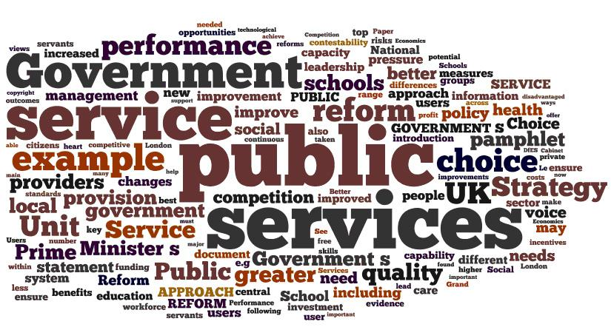
The need for Public Services to work together
Name:_________________ Date:__________________

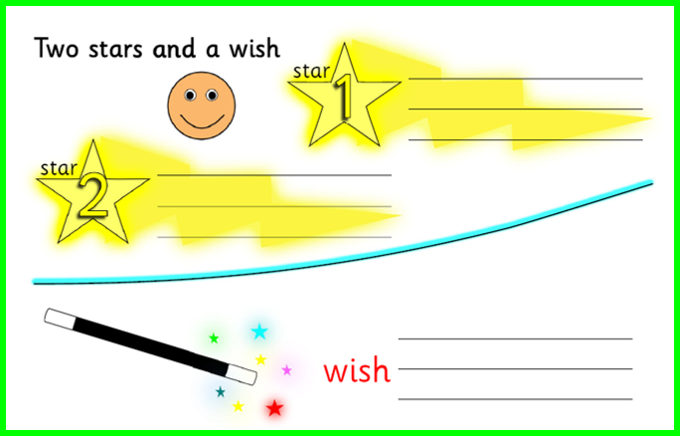
Task 1 – Working Together
Read the Scenario below and then answer the questions provided
On a particularly frosty morning in April, there is a collision on the motorway between a bus and a large lorry. There are a number of suspected injuries and the Bus has been thrown onto its side. All three emergency services have arrived at the scene.
1. Which emergency service will establish a ‘cordon’ around the area? _________________________________________________________
2. Why would a ‘Cordon’ be needed? ________________________________________________________________
3. Which service would provide any necessary medical care? ________________________________________________________________
4. Which service would extract any injured people from the vehicles? ________________________________________________________________
5. Which service will maintain security at the scene of the incident? ________________________________________________________________
6. Why is it important that the scene be kept secure? ________________________________________________________________________________________________________________________________________________________________________________________________________________________________________________________________
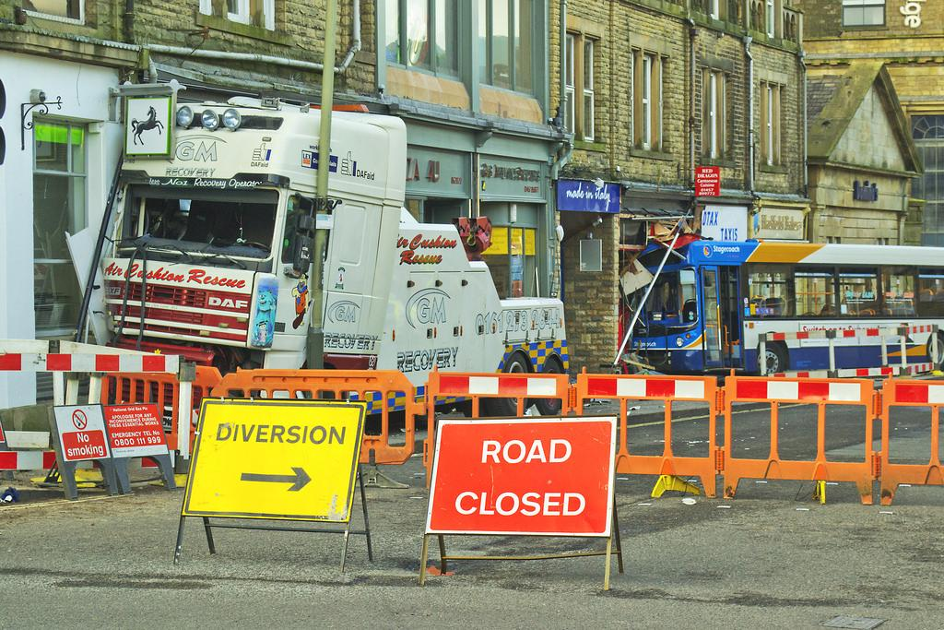

Task 2 - Promoting Efficiency
Public Services work together to promote efficiency.
What does efficiency mean?
________________________________________________________________________________________________________________________________
How will the following help the Public Services to be more efficient when working together:
 | Meaning | Helps efficiency because….
Planning | the public services will make all arrangements in advance so that everyone knows what is happening. | If they plan in advance, everyone will know what they need to do so nothing gets missed out and no one is trying to do the same thing.
Coordinating activities
Teamworking
Using each organisation’s expertise

Task 3 - Benefits of Working Together
There are many benefits of working together. Explain how the following issues will be addressed (solved) by working together:
Continuity of business in day-to-day life ____________________________________________________________________________________________________________________________________________________________________________________________________________________________________________________________________________________________
Effective use of resources
____________________________________________________________________________________________________________________________________________________________________________________________________________________________________________________________________________________________
Public health and safety
____________________________________________________________________________________________________________________________________________________________________________________________________________________________________________________________________________________________
Prevention of crime and terrorism
____________________________________________________________________________________________________________________________________________________________________________________________________________________________________________________________________________________________

Task 4 - Management of Incidents
At an incident, different Public Services will work together to manage the situation. Link the function to the correct Emergency Service:
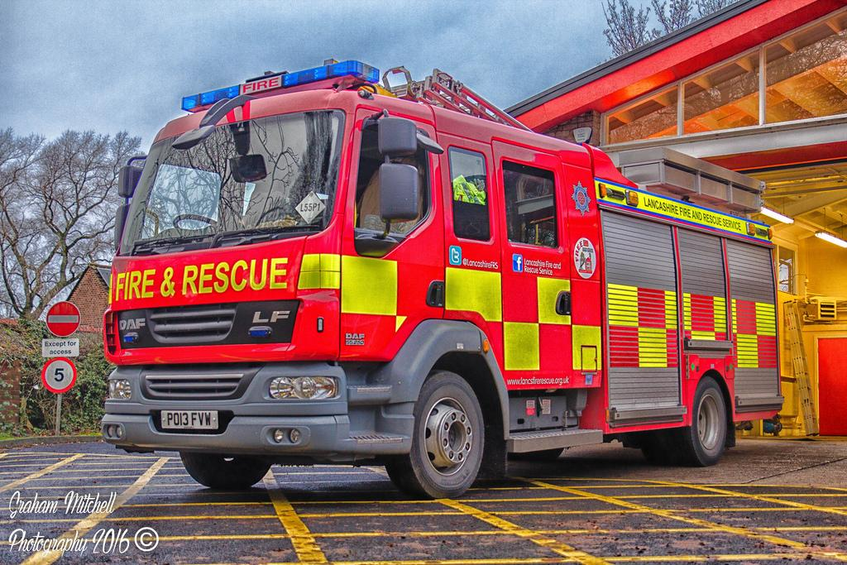
Assess situation

Coordinate rescues
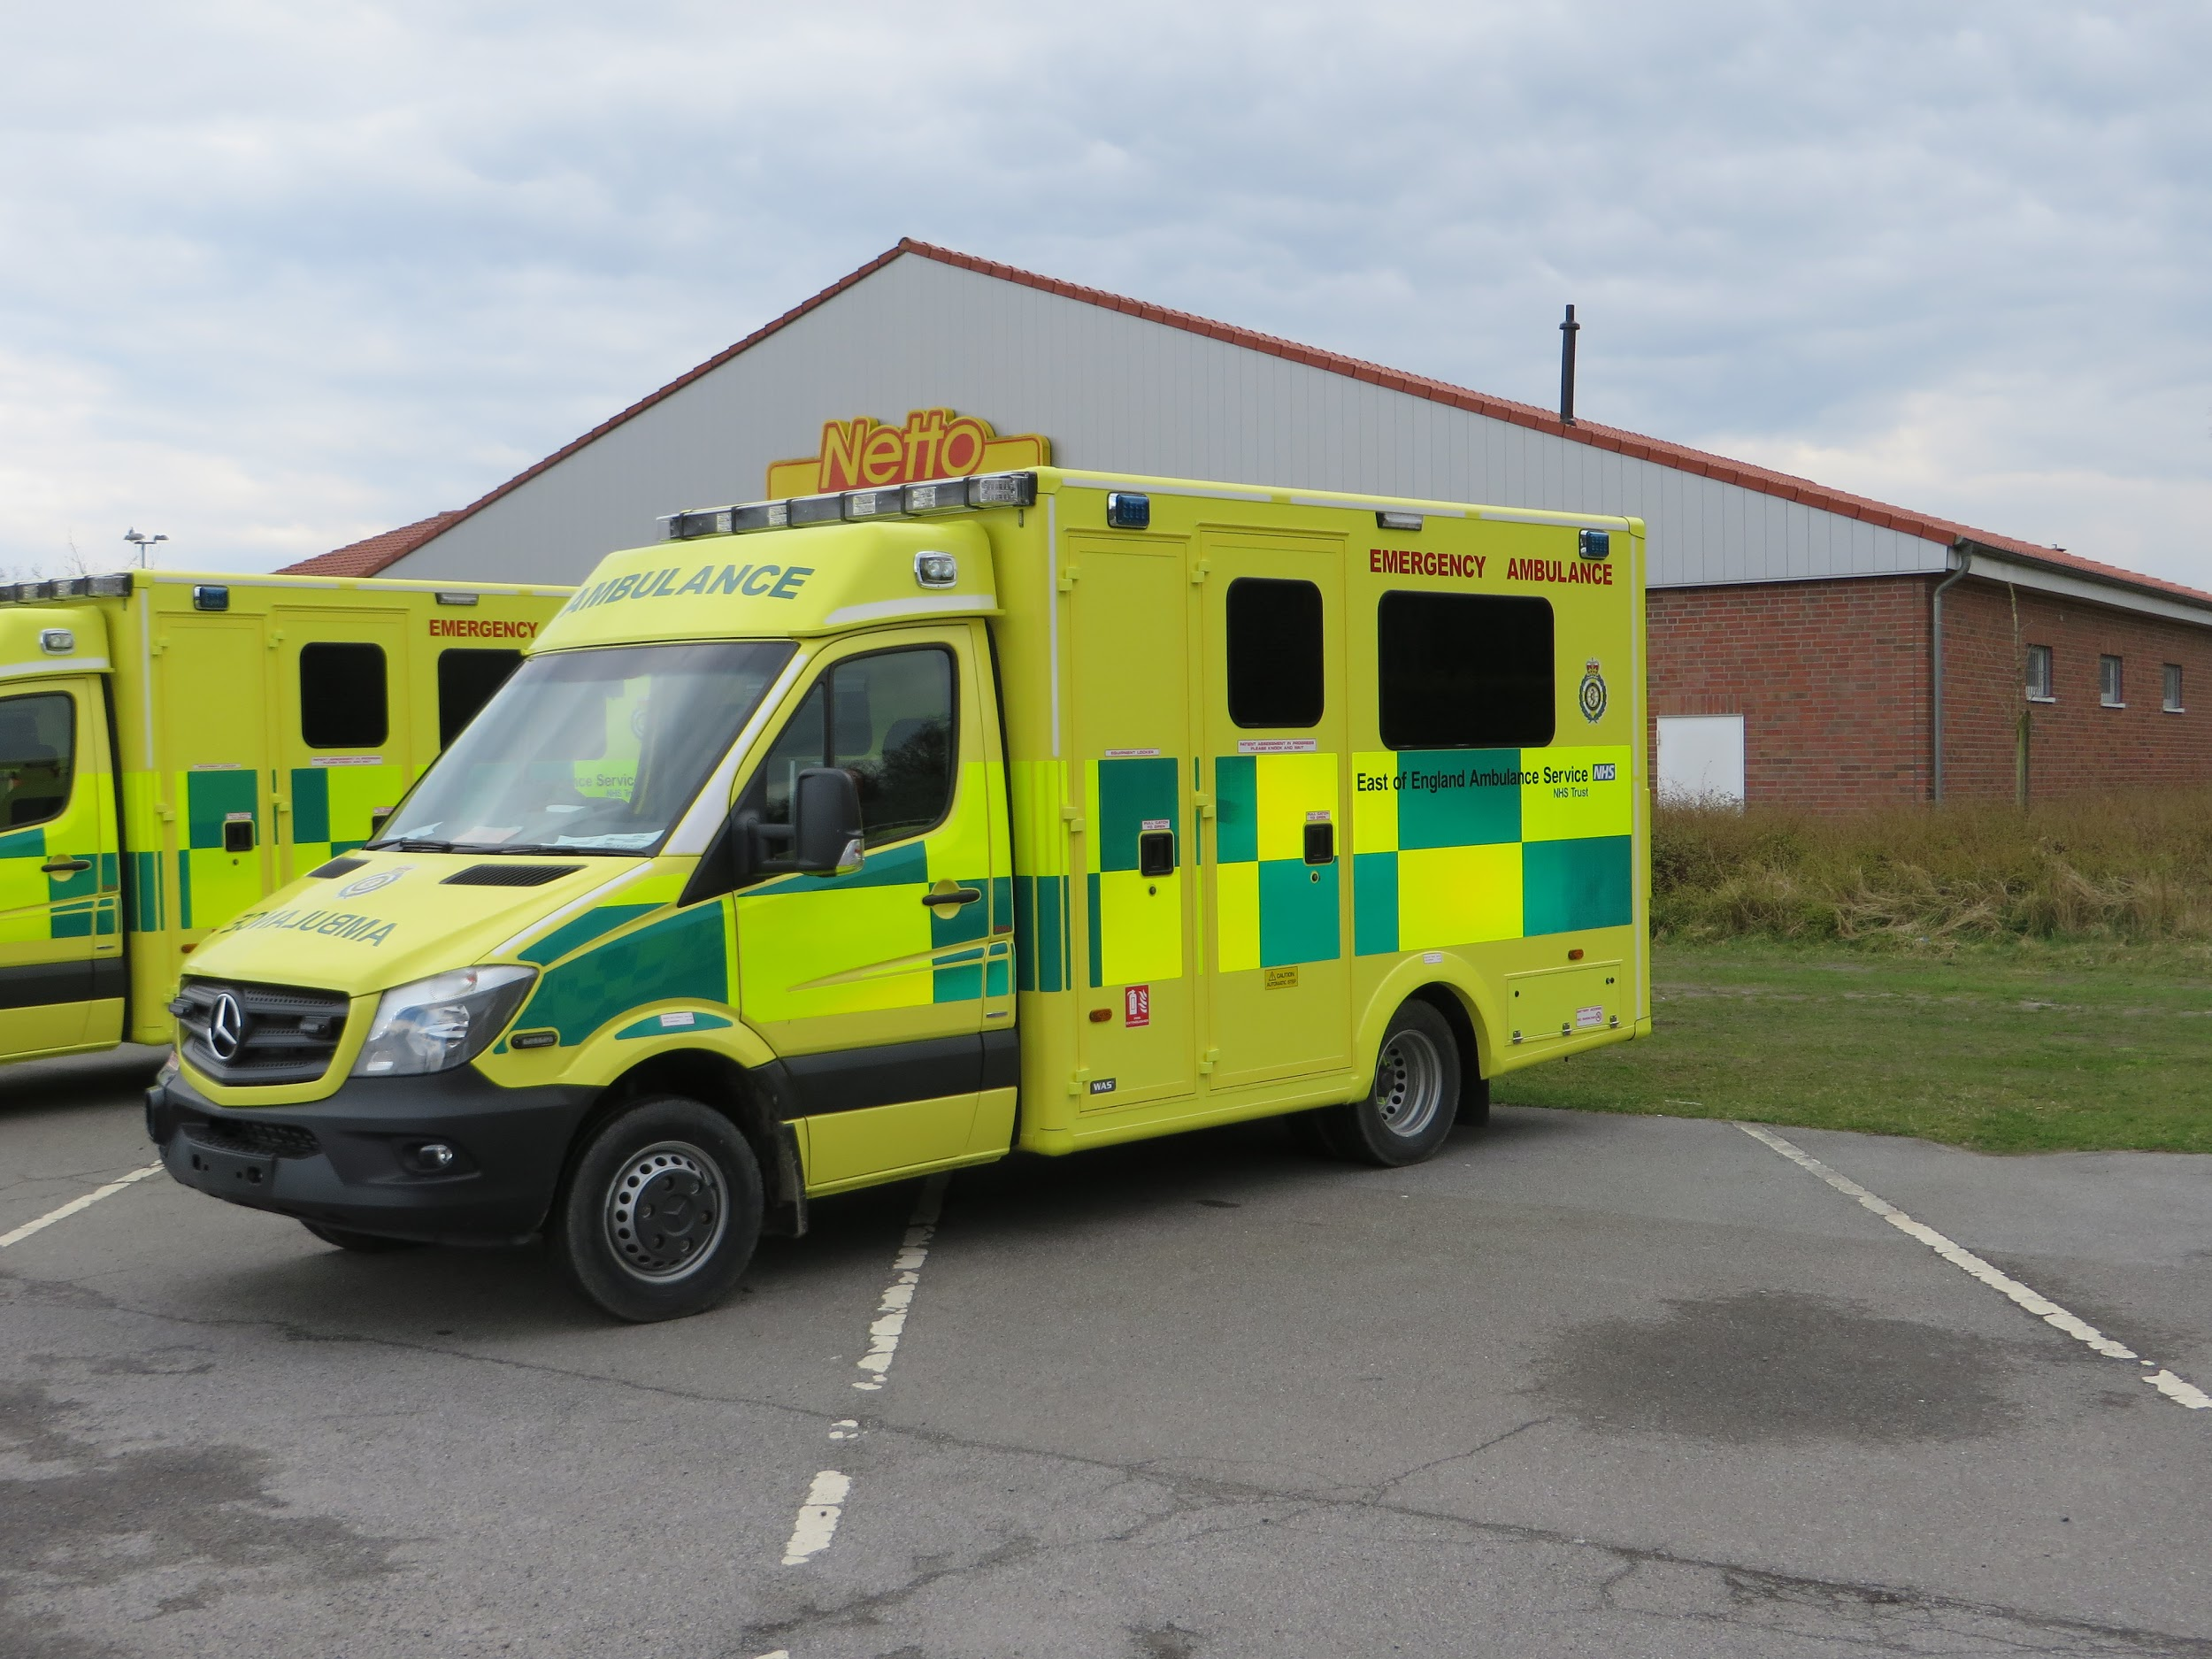
Provide emergency medical care

Maintain the security of
the incident scene
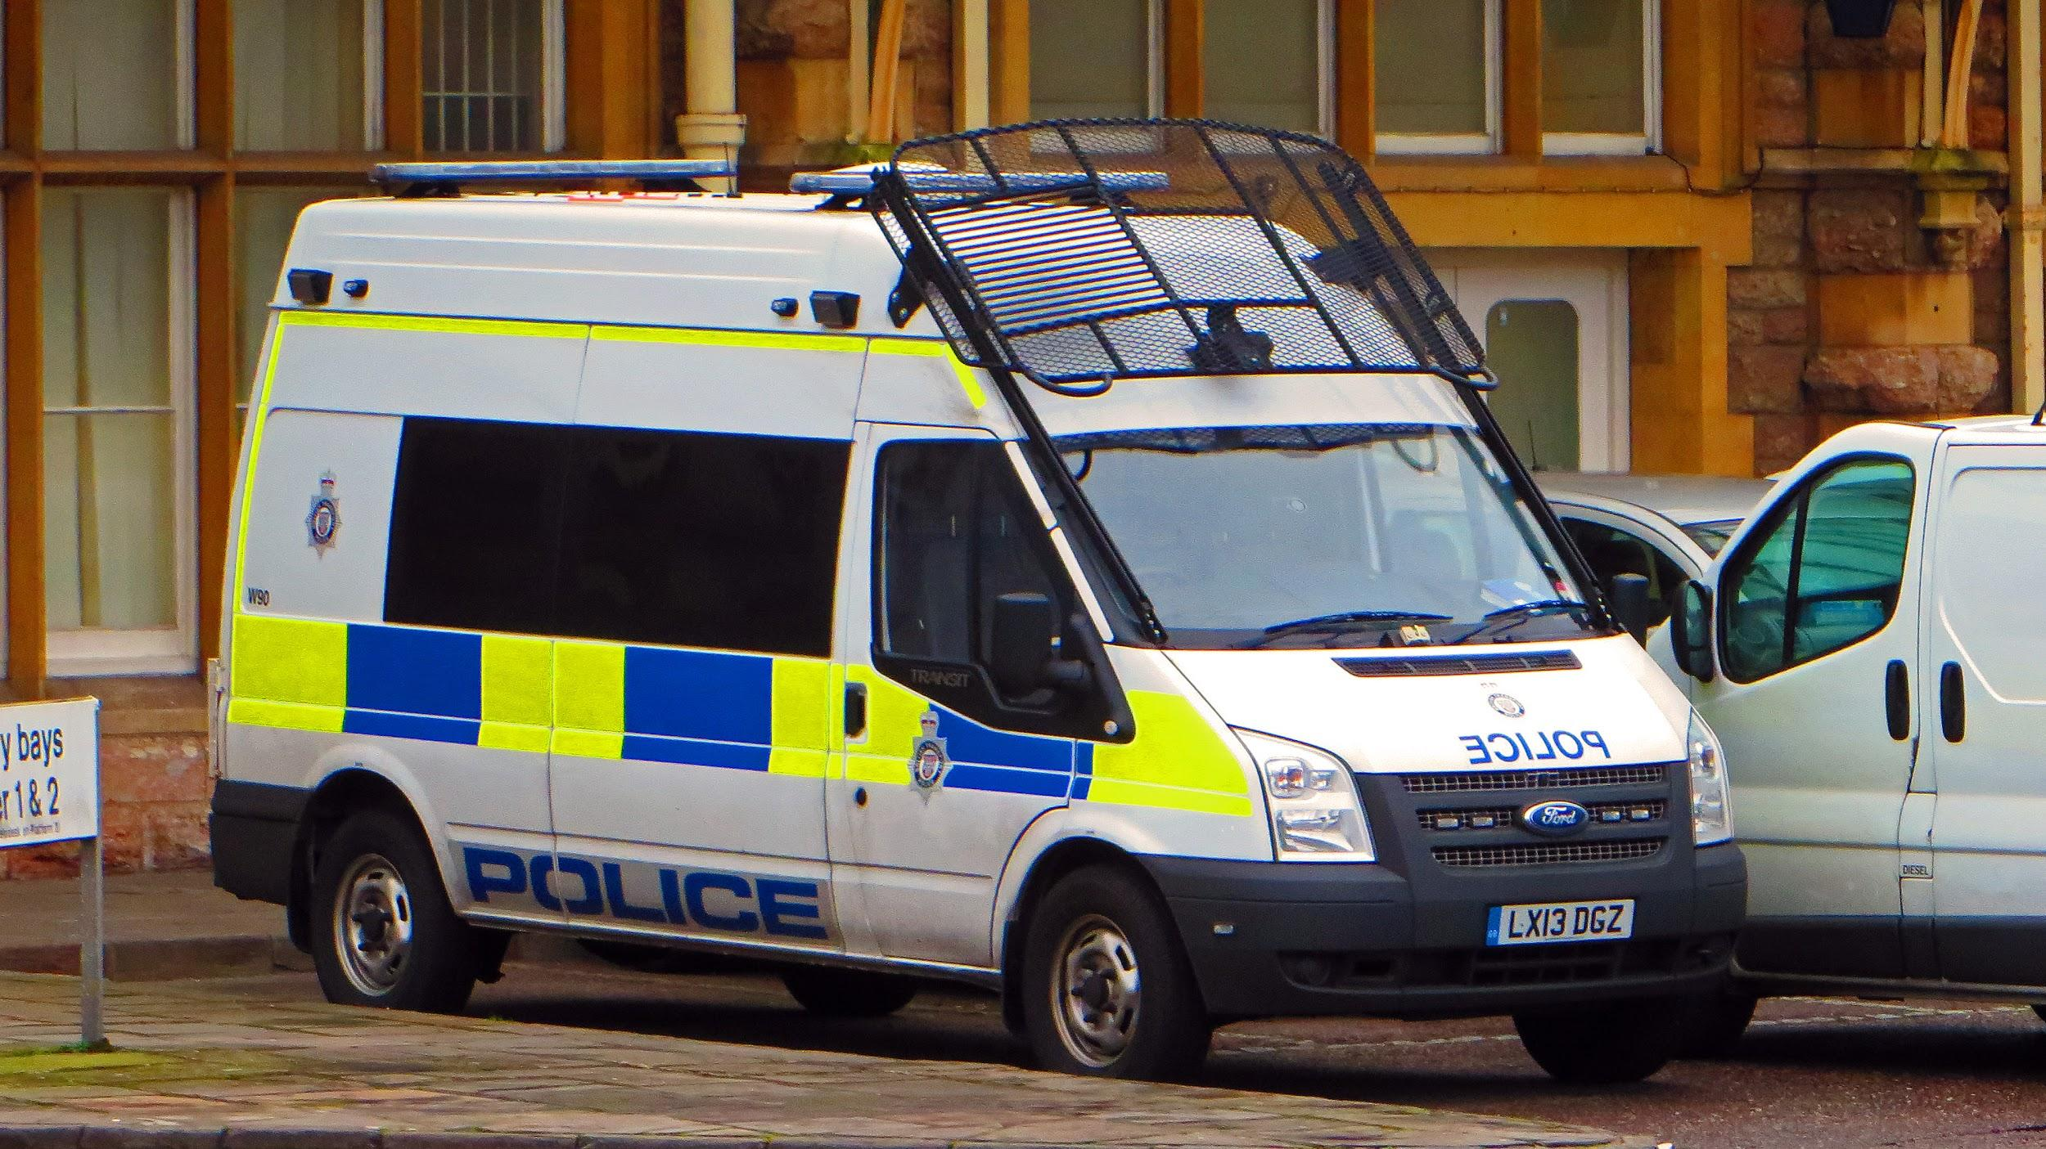
Keep the public away

Minimise impact on wider community

Why is it important that the security of the incident scene is maintained?
____________________________________________________________________________________________________________________________________________________________________________________________________________________________________________________________________________________________

Task 5 - Communication Pathways
When attending an incident. It is important that the Public Services can communicate well with each other. For each of the reasons below, Explain why it is important.
Why is it important to identify and establish communication pathways (how do the public services talk to each other at incidents)?
Orders and instructions are passed down quickly and accurately (correctly)
Leaders are kept informed of developments
Communication systems (like radios) are compatible
Information can be passed to people not at the scene (relatives, media etc)
E.g. so that crucial time is not wasted that could put lives at risk

How will the public services communicate during an emergency?
____________________________________________________________________________________________________________________________________________________________________________________________________________________________________________________________________________________________

Task 6 - Why the Public Services work together
In the boxes, explain how the following can be achieved by working together.
To manage budgets

To meet aims and objectives (targets)

To meet performance measures (targets set by government)

To spend public money wisely

Task 7 - Negative impact of failure to work together
If the public services do not work together, it can have a negative impact on their performance. Explain the following impacts:

 | Means | Has a negative impact because
Ineffective Performance | the Public Services won’t work as well as they possibly could | it may mean that emergencies are not handled as quickly as possible or non emergencies are not handles as they are not a priority
Lack of Coordination
Ineffective use of funding
Lack of accountability

Revision quiz
BTEC Level 2 First Public Services: Unit 1
Surname: |  | Forename:

Instructions
- Write your name in the table above.
- Answer all questions.
- Write your answers in the spaces provided.

Information and advice
- The number of marks that each question is worth is shown in brackets on the right hand side of the page.
- Read each question carefully.
- These practice questions are not actual exam questions but have styled in a similar style as a practice aid.

Two heavy goods vehicles have collided on a busy motorway junction. Several smaller cars are also involved and rush hour is approaching. There are 16 known casualties. The incident requires the involvement of a range of public services working together effectively.

(a) Name one emergency service which would be involved in this incident. (1)

____________________________________________________________________

In planning for incidents like this, the services have to consider how to minimise the impact on the wider community.

(b) Describe the impact that this incident could have on the flow of traffic and what the services could do to minimise it. (2)

____________________________________________________________________________________________________________________________________________________________________________________________________________
____________________________________________________________________

The public services have to work together to ensure that casualties are rescued and treated, and that the scene is protected.

(c) Name the service that would be responsible for protecting the incident scene. (1)
____________________________________________________________________

(d) Explain two ways in which services work together to ensure casualties receive effective treatment. (4)

____________________________________________________________________
____________________________________________________________________
____________________________________________________________________
____________________________________________________________________
____________________________________________________________________
____________________________________________________________________
____________________________________________________________________
____________________________________________________________________
(Total for Question 4 = 8 marks)

In December 2013, the east coast of England suffered severe flooding after the worst storm surge in 60 years. Areas across Lincolnshire, Norfolk and East Yorkshire were particularly affected, and towns such as Boston were badly flooded. Emergency services from across the affected areas responded to the flooding with rescue and evacuation activity, and local authorities set up alternative accommodation in public buildings such as local schools and leisure centres.
(a) Explain one way in which the public services work together to manage severe weather events. (2)

____________________________________________________________________
____________________________________________________________________
____________________________________________________________________
____________________________________________________________________

(b) Explain one way in which the public services work together to ensure continuity of business and everyday life. (2)

____________________________________________________________________
____________________________________________________________________
____________________________________________________________________
____________________________________________________________________

(Total for Question 5 = 4 marks)

