Transition pack for wjec food science and nutrition

Get ready for level 3!!
A guide to help you get ready for
level 3 wjec food science and nutrition.

So are you considering
Level 3 food science and nutrition?
This pack contains a programme of activities and resources to prepare you to start Level 3 Food Science and Nutrition in September. It is aimed to be used after your complete your GCSE throughout the remainder of the Summer Term and over the summer holidays to ensure you are ready to start the course in September.
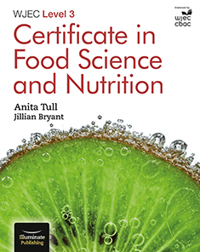

https://www.wjec.co.uk/en/qualifications/food-science-and-nutrition-level-3
INTRODUCTION TO NEW FOOD COURSE
This new Level 3 course has been introduced to replace the old Food Technology/Food and Nutrition A Levels.
The Diploma course is studied over 2 years, alongside other A Levels.
The course is graded as L3 Pass, L3 Merit, L3 Distinction and L3 Distinction*. UCAS points are the equivalent to A level grades E, C, A and A*.
If only the first year of the Diploma course is taken, then the award becomes a ‘Certificate in Food Science and Nutrition’, rather than a full ‘Diploma in Food Science and Nutrition’, and the UCAS points are equivalent to AS level grades.

WHY CHOOSE FOOD SCIENCE AND NUTRITION?
Food Science and Nutrition is an exciting subject that is suitable for any student who is interested in developing their knowledge in:
- The Science of Food and Food Safety
- Nutritional Needs of Specific Groups
- Food Preparation, Cooking and Presentation
- Current Food Initiatives and Healthy Eating Guidelines

OUR APPROACH TO TEACHING AND LEARNING
The department has excellent resources which will enable students to experience a wide range of learning opportunities.
- There is strong emphasis on practical work – the students will develop their high level food skills each week. Demonstrations will be regularly given to introduce students to new techniques. These practical lessons will not only increase their knowledge of food preparation but also prepare the learners for the assessed practical assignments at the end of the course.
- We have a flexible teaching approach but understand the need to complete homework, respect deadlines and set high standards.
- We use a range of quality learning materials, most of which have been designed in-house. Students will each be given a recipe collection pack for their practical work. Coursework booklets are used to help guide them through every step of their assignments.
- We have a range of online learning and assessment materials.
YEAR 1 TOPICS & ASSESSMENT
Students will be assessed by one piece of coursework and one written examination in the summer of year 1.
Component 1 – Examination
Written examination: 1 hours 30 minutes, plus 15 reading time
50% of Year 1 qualification
Short and extended answer questions
Topics include:
- Food Science and Nutrition
- Food Safety
- Nutritional Needs of Different Population Groups
- Diet Related Diseases
- Dietary Planning

Component 2 – Coursework
50% of Year 1qualification
Students are given a specific scenario for which they must produce professional, high skilled dishes. They will plan, prepare, present and evaluate their work. Detailed documentation required.

YEAR 2 TOPICS & ASSESSMENT
Students will be assessed by two pieces of coursework to be completed the summer of year 2.
Topics covered:
- Micro-organisms
- Preservation
- Food Intolerances/Allergies
- Food Safety
- Planning research
- Managing an investigation

Component 1 – Coursework 1
‘Ensuring Food is safe to Eat’
50% of Year 2 qualification
Food Safety assignment based on specific scenario, which will include producing a food safety resource and risk assessment.
Scenario is set by the examination board and released during the spring term.

Component 2 – Coursework 2
‘Current Issues in Food Science and Nutrition’
50% of Year 2 qualification
Investigation into any food related issue of own choice

ENTRY AND SKILL REQUIREMENTS
What are the entry requirements for Food Science and Nutrition?
• Minimum 5 GCSE’s at grade C or equivalent
• Though desirable, it is not essential that you have previously studied food. Having a real interest in the subject is what is most important.

Please bear in mind there is a large number of practical lessons, especially in the first year, so it is important that this should be an area you particularly enjoy.

PROGRESSION
An understanding of food science and nutrition is relevant to many industries and job roles such as manufacturing, product design, food stylist, food journalism, health promotion, dietitian/nutritionist, nursing, sports coaching, etc.
Together with other relevant L3 qualifications such as A Level Psychology, Law, Biology, Physical Education, Chemistry, Sociology, Maths, etc, students will be able to progress to degree courses such as:
- BSc Food and Nutrition
- BSc Food Development and Innovation
- BSc Dietetics and Human Nutrition
- BSc Human Nutrition
- BSc (Hons) Public Health Nutrition
- BSc (Hons) Food Science and Technology

Examples of universities offering such courses, where past students have progressed onto include: Birmingham University, University of Nottingham, University of Leeds, Worcester University, Bath Spa University, University of Huddersfield, Coventry University and Cardiff Metropolitan.
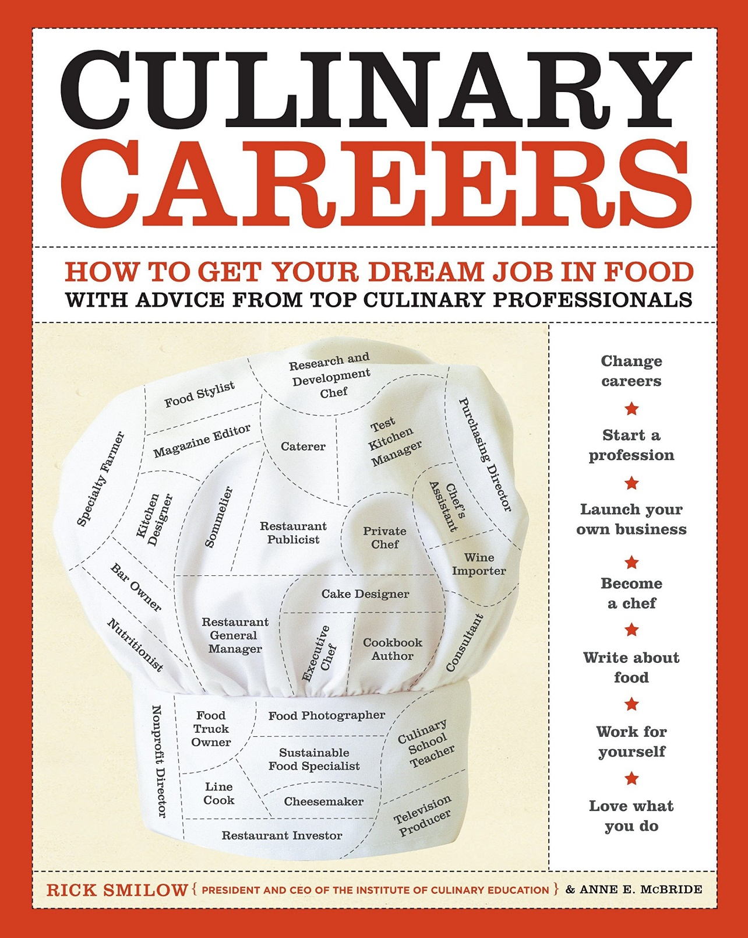

Book recommendations
Kick back this summer with a good read. The books below are popular food science and nutrition books and textbooks, this will help you extend your understanding.
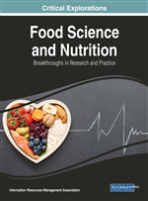
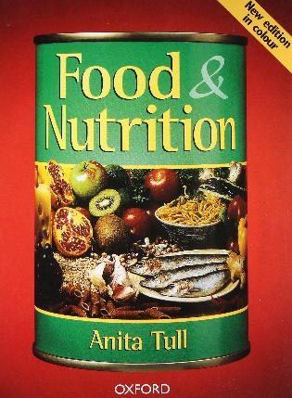

Cooking show recommendations
Cooking shows have consumed day time television with many channels now broadcasting a whole range of them. THERE ARE SOME LISTED BELOW, SO WHATEVER TICKLES YOUR FANCY GET INSPIRED!!

SUBJECT TASK
WJEC Level 3 Food Science and Nutrition
Summer Bridging Task
The purpose of giving you a summer bridging task
i. To provide a bridge from level 2 to level 3 study, and lead into the early stages of the course
ii. To engage you in independent learning which is required at level 3
iii. To encourage you to develop your work ethic and commitment to study
iv. To measure your suitability for the course and assess your initial levels of achievement

All of your work must be typed and clearly presented – please reference your work where possible
Task 1: Define the following key terms (30mins):
- Macro-nutrient
- Micro-nutrient
- Allergen
- High-risk food
- Cross-contamination
- Food fortification
- Malnutrition
- Protein complementation
- Energy balance
- Glycaemic index

Task 2: Below is a recipe for Lasagne (30mins):
Describe, in detail, how you could alter the recipe to make it:
a) higher in fibre
b) lower in fat
c) lower in salt
d) suitable for someone who is a Coeliac
e) suitable for someone who is a Lacto-ovo vegetarian
f) suitable for someone who is a Vegan
g) suitable for someone who is lactose intolerant

Task 3: Carry out some research on food safety legislation. Demonstrate your knowledge and understanding of The Food Safety Act 1990 and The Food Safety and Hygiene (England) Regulations 2013 by producing an information document (in any format). The document should also include a clear outline of what HACCP means/entails for food businesses (90mins).
Useful websites: https://www.food.gov.uk https://nutrition.org.uk
Useful books: WJEC Level 3 Certificate in Food Science and Nutrition A Tull/J Bryant ISBN 9781911208587 BRING YOUR WORK TO YOUR FIRST LESSON
WJEC FOOD SCIENCE AND NUTRITION
PAST PAPER

