Relationships, sex and health education: guides for parents

Dear Parents
Please click on the picture which will take you to the website.

Documents

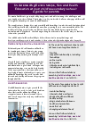

Understanding relationships, sex and health education at your child’s school: secondary
PDF, 429KB, 2 pages

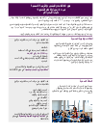

Understanding relationships and health education in your child’s school: secondary, Arabic
PDF, 605KB, 2 pages
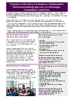

Understanding relationships and health education in your child’s school: secondary, Somali
PDF, 163KB, 2 pages
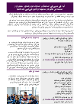

Understanding relationships and health education in your child’s school: secondary, Urdu
PDF, 134KB, 2 pages

